27.44: (a) The force on each segment of the coil is toward the center of the coil, as the net force and net torque are both zero.
(b) As viewed from above:
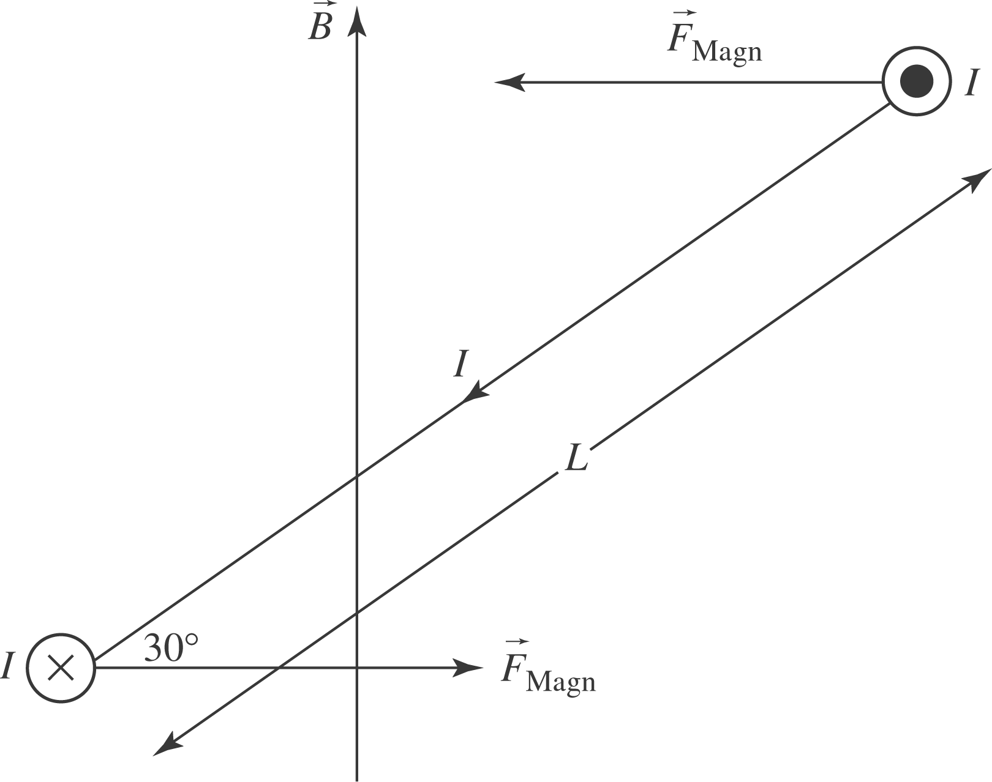

As in (a), the forces cancel.

